PROTEUS SCREENSHOTS OF LAB 3

TASK 1

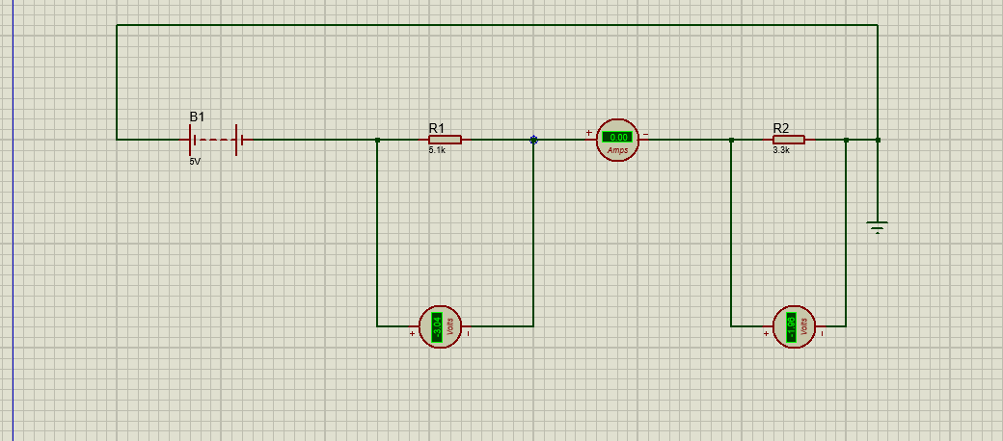

TASK 2
